Password Strength Analyzer
Name: SHREYA PANCHAL
Organization: THIRANEX Virtual Internship India

Objective
To develop a secure login web application using Flask with hashed passwords, input validation, and session management.

Key Features
- Check password length, complexity, and uniqueness
- Suggest stronger password alternatives
- Optional: Prevent reuse of old passwords using a database
- Learn password security and basic cryptography concepts

Task 4: secure Login system (Kali Linux)
Step 1: Display current directory- #pwd
Step 2: Create Project Folder
#mkdir Secure_Login_System- create folder
#cd Secure_Login_System- Open project folder.
#pwd- check
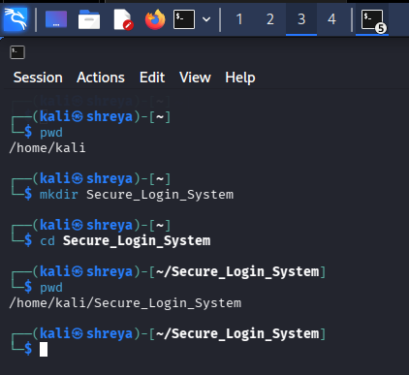
Step 3: Install Required Packages
#sudo apt update- install
#sudo apt install python3-flask -y -Install Flask
#sudo apt install python3-bcrypt -y -Install bcrypt
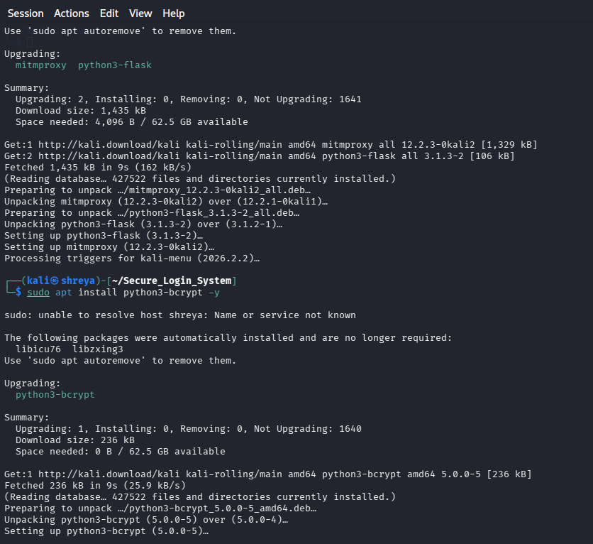
Step 4: Create Python File- #nano app.py
Step 5: past thecode
from flask import Flask
app = Flask(__name__)
@app.route("/")
def home():
return "Secure Login System"
if __name__ == "__main__": app.run(debug=True)
Step 6: Save the file
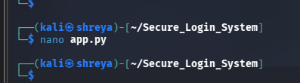
Step 7: Run Program- #python3 app.py
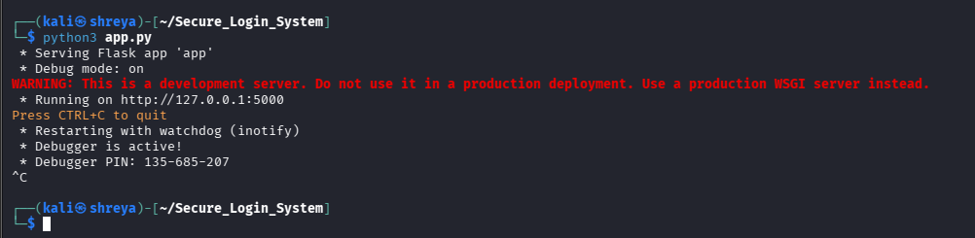
Step 8: Open Browser
http://127.0.0.1:5000
Output:
Secure Login System
